Mathematics
The Vocabulary of Location:
How Do I Get There?
Fourth – Fifth Grade Levels

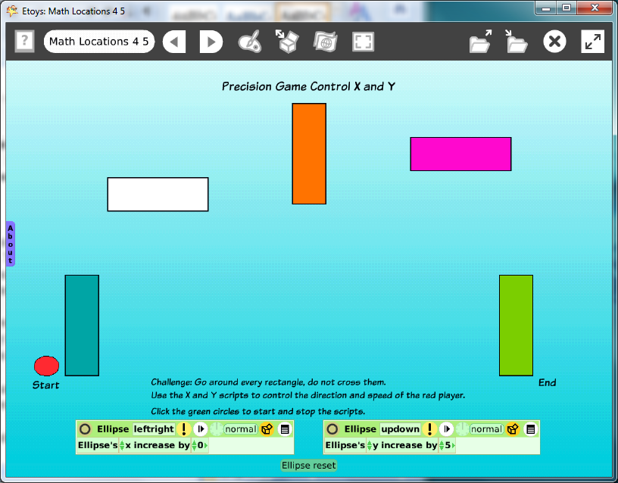

Introduction: | Students use Etoys to explore the location/s of a moving object on a grid. The vocabulary and concepts are useful on and off of the computer. The geometric shapes are positioned using coordinates on the X/Y axis.  Students will use the location and heading information to move efficiently from one rectangle to another. The pen trail shows the moves so, accuracy counts.
Topic: | Build a math vocabulary of position coordinates and distance. Practice estimating distances and heading.
Subject: | Mathematics
Time: | Three Labs
Description: | Students use the maze created in the Technology Passport Mathematics for 2-3 grade levels. Or, make a new maze with objects from Supplies.
Vocabulary: | above, top, right, upper, center, on, up, beside, behind, below, bottom, left, lower, edge, near, down, before, between, headings, X and Y locations, increase by, decrease by, positive numbers, negative numbers
Evaluation Criteria: | Use X/Y co-ordinate data to control the position of objects.  Uses the heading information efficiently.  Know how to Find and Keep projects.  Write scripts to make objects move and to change direction.
Teacher Information:  Etoys Quick Guides: Click the question mark in  Etoys to open the set of tutorials about basic tools and techniques. | Etoys Quick Guides: Click the question mark in Etoys to open the set of tutorials about basic tools and techniques.\  Use Etoys Quick Guides if the lesson mentions unfamiliar tools or techniques. Give students time to read them too.
Goals: | Students develop a vocabulary of position and place relationships useful in mathematics on and off the computer.  Students use x and y axis values to position geometric shapes and then to move an ellipse efficiently from one location to the next.  Students apply the concepts of x and y increase by positive and negative numbers to move the player around the rectangles.
Lesson 1:  Two labs  Script Tiles: Exact Location  Script Tiles:  X and Y Tiles  Script Tiles: Forward by  Script Tiles: Heading  Script Tiles: Pen Use  Navigator Bar: Keep Find Projects | Form the maze with five rectangles from Supplies and position them so that all are at related points on the grid.  Write two scripts, X increase by and Y increase by. Use them to move around the maze.  Change the directions with one or both scripts ticking.  Give students time to experiment with their project and then to try mazes done by other students. Make a pen trail in one project be the backward path for another trial. Change the color of the pen so the reverse trail is visible.  Ask students to draw a trail that touches all rectangles with the smallest number of moves and turns possible.  Discuss: How are the mazes similar and how are they different? What makes one maze harder than another? Why?  Students may wish to modify their maze after experimenting with other mazes. Give them time to do so.  Keep it as a new project called namemazenov08  For example: katemazenov08
Extend Lesson 1  One lab  Menus: Scriptor Icons Set | Ask students to estimate how large or small the forward number needs to be to reach the next rectangle in one leap. Change the pen trail to dots instead of lines. The more accurate their estimate the fewer dots will show.  Click the exclamation mark to run a script once.
Student Information: | Show students an example screen if an LCP projector is available or use a computer and or show each small group one example of a maze.
Standards: | Illinois Performance Standards: Mathematics  Fourth Grade: To use letter-number pairs and ordered pairs of  numbers to locate points on a rectangular grid and to use a map scale. 8B, 7C  Fifth Grade: Review coordinate grids 8A, 8B  National Educational Technology Standards (NETS)  1. Basic operations and concepts  Students demonstrate a sound understanding of the nature and operation of technology systems.  Students are proficient in the use of technology.  3. Technology productivity tools  Students use technology tools to enhance learning, increase productivity, and promote creativity.  Students use productivity tools to collaborate in constructing technology-enhanced models, prepare publications, and produce other creative works  4. Technology communications tools  Students use telecommunications to collaborate, publish, and interact with peers, experts, and other audiences.  Students use a variety of media and formats to communicate information and ideas effectively to multiple audiences.
Resources: | Etoys Help Quick Guides: Open Etoys and click the question mark in the Navigator Bar to open a set of interactive tutorials that introduce basic tools and techniques.  EtoysIllinois.org for projects, tutorials, and lesson plans  Squeakland.org Etoys software
kh
April 9, 2012

